

**Hungry Robots**

HR Payroll Process

Detailed Process Description

Version 1.0

**Revision History**

|  |  |  |  |
| --- | --- | --- | --- |
| Date Issued | Version | Description | Author |
| 04/07/2020 | 1.0 | Draft | Mohammed Adam  Premal Nayee  Tshepiso Khoarane |

**Contributors**

The content of this document has been authored with the combined input of the following group of key individuals.

|  |  |  |
| --- | --- | --- |
| Name | Role | Area |
| Mohammed Adam | RPA Consultant | Hungry Robots |
| Premal Nayee | RPA Consultant | Hungry Robots |
| Tshepiso Khoarane | RPA Consultant | Hungry Robots |
| Chris Lucas | HR Manager | QA ltd |

**Business Sign-off**

The following table contains the people required to sign-off and/or review this document and those that require the document for information only.

|  |  |  |
| --- | --- | --- |
| Name | Department | Responsibility |
| Tshepiso Khoarane | Hungry Robots | Review |
| Premal Nayee | Hungry Robots | Review |
| Mohammed Adam |  |  |
| Chris Lucas | HR | Information / Sign off |

**Document Classification**

|  |  |
| --- | --- |
| Classification | Company Confidential |
| **Definition** | Information is company confidential and needs to be protected |
| **Context** | Where loss of information confidentiality would result in significant harm to the interests of the Organisation, financial loss, embarrassment or loss of information |
|  |  |
|  |  |

Contents

1 Introduction 4

2 Manual Process 4

2.1 Overview 4

2.2 Detailed Process Flow 6

3 Automation Proposal 7

3.1 Overview 7

3.2 Automated Process Flow 9

3.3 Target Systems & User Requirements 10

3.4 Impacted Business Areas 10

3.5 Workload 11

3.6 Operational Constraints 12

3.7 Delivery 12

3.8 Contact List 12

4 Automation Details 13

4.1 Automation Walkthrough 13

4.1.1 *First robot action* - Employee payroll table (starting point) 13

4.1.2 Config for collating employee payroll details 13

4.1.3 Dispatch employee payroll emails to the queue 13

4.1.4 Perform database changes on queue items 14

4.1.5 *Second robot action* 15

4.1.6 *third robot action* 16

4.2 Reporting 18

4.2.1 Business Exception 18

4.2.2 System Exceptions 18

4.2.3 Triggers 18

# 1 Introduction

HR is an extensive role within a company, with responsibilities ranging from employee on boarding to payroll. With this project we will be looking closely at the payroll process and evaluating how it can be automated to save time and costs. The current process includes many sections such as receiving emails for hours worked so this can be updated onto the database for both consultants and employees. These details will be passed to the payroll team so they can extract relevant information to make payslips for the payments to be processed. This has been identified as the perfect candidate for automation due to its sequential nature. This document will focus on the payroll collation of details to making the payslips.

# 2 Manual Process

## 2.1 Overview

This process is initiated 2 weeks before the pay date. Each employee's working hours should be emailed by the deadline date. Then a few HR Employees will then go through the following stages:

**Collate hours worked from in house employees**

* Step 1: Send an email to each employee with the time sheet to fill in and send back
* Step 2: Read an unread email in Outlook
* Step 3

Step 3a: Is subject “Add employee payroll hours”

Move to folder “Add employee payroll hours”

Add hours to employee database

Step 3b: Is subject “Change employee payroll details”

Verify identity of person changing details

Move to folder “Change employee payroll details”

Change user details in employee database

Step 3c: Is subject “Delete employee from payroll”

Seek approval from heads of departments

Move to folder “Delete employee from payroll”

Delete employee details in database

Step 3d: Is subject none of the above subjects

Move to folder “Other”

* Step 4: Check if any more emails

If so, then repeat go to step 2

If not, then continue

The database is an Excel sheet stored in the database folder.

**Collate hours worked from International Consultants**

* Step 1:Check Outlook outbox to see if email from consultants have been received
* Step 2: If subject “Invoice” with PDF file attached in email

Download PDF to PDF Folder

Move Email to “Invoice” Folder Inbox

* Step 3: Open each Invoice PDF

Extract Hours worked and input this into the consultant database

* Step 4:Save this pay date database into local folder.

**Payslip Processing**

International consultants

· Step 1: access exchange rate website, scrape current exchange rate for chose country, store the value as a variable

· step 2: read into automation the updated employee database that has the updated worked hours and sick days

· step 3: multiply the total cost of the employee with the exchange rate

· step 4: write the updated value into the pay period database

Payslips for all Employees

· Step 1: read each employees data from pay period database

· Step 2: each employees detail into a PDF template for payslips

· Step 3: email payslip to each employee

· Step 4: save payslips in local file for pay period

## 2.2 Detailed Process Flow

**Collate hours worked from in house employees**

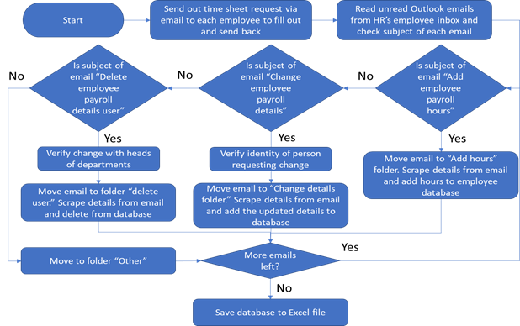

**Collate hours worked from International Consultants**

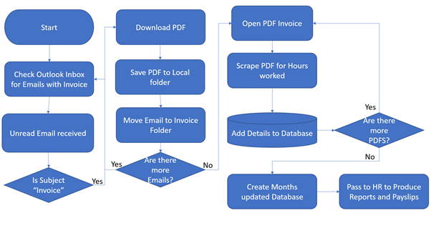

**Payslip Processing**

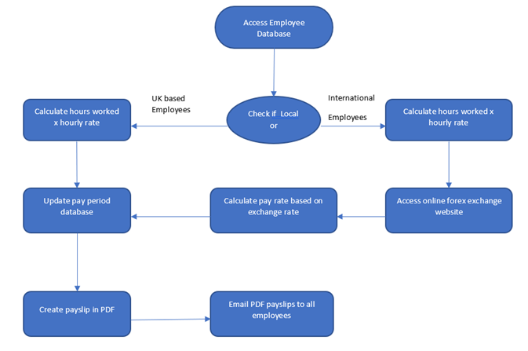

# 3 Automation Proposal

## 3.1 Overview

Below is the proposed automation for the above manual flow. The automation will follow manual flow very closely.

**collating employee time sheets**

* Step 1: Send an email to each employee with the time sheet to fill in and send back
* Step 2: Read an unread email in Outlook
* Step 3

Step 3a: Is subject “Add employee payroll hours”

* + - Move to folder “Add employee payroll hours”
    - Add hours to the database

Step 3b: Is subject “Change employee payroll details”

* + - Verify the sender email with the employee database
    - Move to folder “Change employee payroll details”
    - Change user details in database
* Step 4: Check if any more emails

If so, then repeat go to step 2

If not, then continue

The database is an Excel sheet stored in the database folder.

**Collating consultants’ invoices**

* Step 1**:** Reading Email

Email Received

Is the subject “INVOICE”?

IF INVOICE – Email moved to INVOICE FOLDER, PDF Downloaded, and saved in local folder.

ELSE: – Email moved to Manual Intervention Folder

* Step 2:Reading Invoice PDF

Open folder path and add all files paths with “.pdf” into array

all PDFs and output into text file

Use REGEX syntax to filter and extract Email Address and Hours worked

* Step 3:Update Employee Tables

Match the consultant employees by their unique email addresses

Input the hours worked into correct field

**Payslip Process**

* Step 1: check that the pay period database is available.
* Step 2: get exchange rate from an online currency website.

the exchange rate must be collected when the payslips are to be made to get the most accurate salary at the time of pay.

* Step3: Multiply the exchange with the total pay.

the total has been previously worked out from the invoices sent in by the consultants.

* Step 4: Update the pay period data bases
* Step 5: Open payslip template and write.

each employee and consultant’s payslip is written on to an excel template and save individually using the employee ID

* Step 6: Convert excel payslip document into PDF format
* Step7: Email the payslips to each employee and consultant.

## 3.2 Automated Process Flow

**Employee Collation Process**

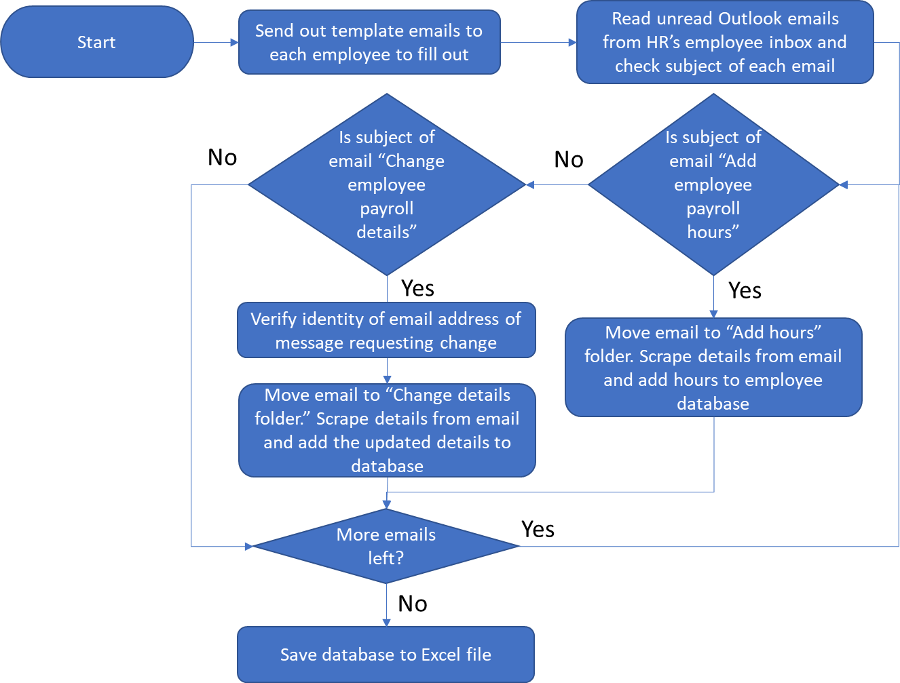

**Consultant collation process**

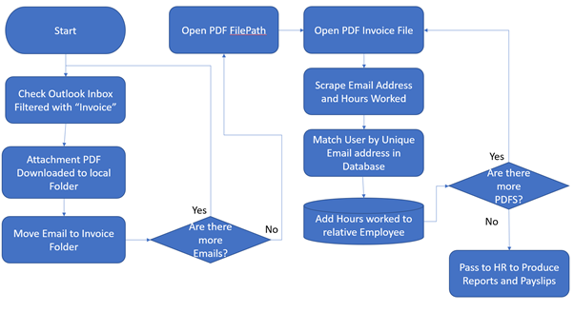

**Payslip Process**

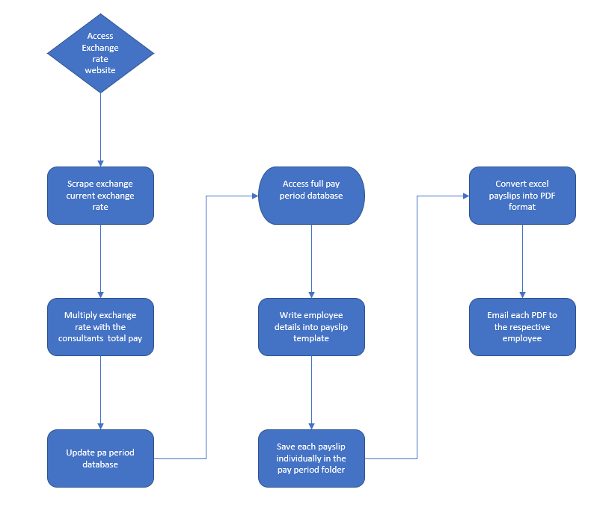

## 3.3 Target Systems & User Requirements

|  |  |  |
| --- | --- | --- |
| Name | Description | User Permissions/Access |
| MS Outlook | Email Inbox | Robot will require read/write access to the receptionist’s mailbox to send and receive emails to everyone in the office |
|  |  |  |
| Receptionist computer |  | Will need access to install robot on receptionist |
| Excel | Employee Database | Should be able to have access to the employee database list and make changes to fill in relevant details. |

## 3.4 Impacted Business Areas

* HR Department - Payroll Team
* Employees / Consultants - May now need to follow certain formats
* The receptionist will notice the difference

## 3.5 Workload

|  |  |
| --- | --- |
| *Number of Employees:* | *40* |
| *Number of Contractors:* | *10* |
| *Total Overall Workers:* | *50* |
| *User Updates Employees per week:* | *10* |
| *User Updates Contractors per week:* | *5* |
| *User Removals per week:* | *5* |
| *How many people do this process per …?* | *3* |
|  |  |
| *Mohammed (Collating consultants’ hours)* |  |
| *Saving Invoice PDFs* | *2mins per employee* |
| *Time Extracting PDF into Database* | *10 mins per employee* |
|  |  |
| *Premal (Collating employee’s hours)* |  |
| *Add hours to employee payroll database* | *10 mins per employee* |
| *Change details to employee payroll database* | *10 mins per employee* |
|  |  |
| *Precious (Payslip Process)* |  |
| *Getting up to day exchange rates* | *2 mins* |
| *Calculating consultants pay in preferred currency and updating salary data* | *5mins per employee* |
| *Creating payslips* | *7 mins per employee* |
| *Email payslips* | *2 mins per employee* |

On average it takes a single person 1,222 minutes (20.37 hrs) to go through this whole process from inputting payroll details to sending out the payslips.

**Automating the steps below will realise an average time saving of 1,222 minutes (20.37hrs) per fortnight:**

* Adding hours worked to employee payroll database (10 minutes) x (40 employees) = **(400minutes) (6.67hrs)**
* Extracting information from PDF and adding into consultant payroll database (12 minutes) x (10 consultants) = **(120 minutes) (2hrs)**
* Updating details on employee payroll database (10 minutes) x (20 Employees) = **(200 minutes) (3.33hrs)**
* Getting the up-to-date exchange rates **(2 minutes) (0.033hrs)**
* Calculating consultant pay in respective currency and updating salary details (5 minutes) x (10 consultants) = **(50 minutes) (0.83hrs)**
* Creating payslips (7 minutes) x (60 Total Employees) = **(420 minutes) (7hrs)**
* Email payslips (2 minutes) x (60 Total Employees) = (**120 minutes) (2hrs)**

## 3.6 Operational Constraints

* No access to company employee database
* Invoices must include the labels, “Email” and “Hours Worked” for the details to be extracted
* All payments to employees need to be paid by a certain date, so payslips must be ready by Friday every fortnight.
* Only PDF files saved in the folder will be worked on.

## 3.7 Delivery

*the complete automation is due to be delivered 10th July 2020.*

## 3.8 Contact List

*RPA Programme Sponsor – Jenny*

*QA Liaison – Chris Lucas*

*RPA Consultant – Tshepiso Khoarane*

*RPA Consultant – Mohammed Adam*

*RPA Consultant – Premal Nayee*

# 4 Automation Details

## 4.1 Automation Walkthrough

### 4.1.1 *First robot action* - Employee payroll table (starting point)

The automation starts off with a table like the one below.

As we have no access to the production data we will be using a fake worker table that was generated using a fake person generator.

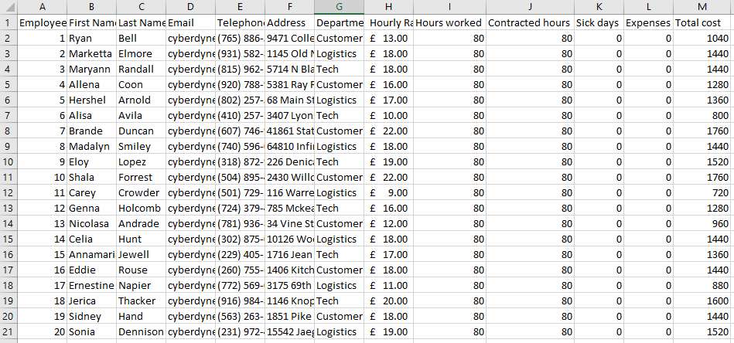

*Figure 1: The employee payroll table. Showing the format of the employee table. Named “Employee_payroll_table_date”. e.g. “Employe_payroll_table_08_07_2020”*

### 4.1.2 Config for collating employee payroll details

We start our automation with the config file. Here is where all configurable details such as the employee excel file path and the HR’s mailbox is recorded.

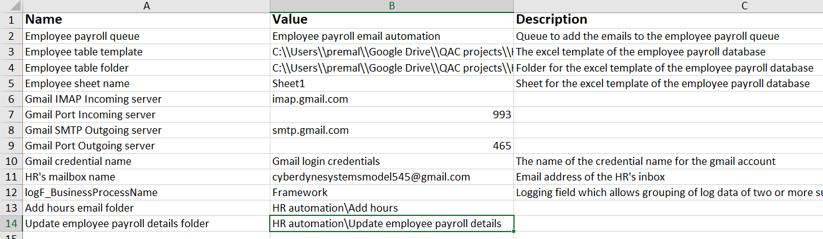

*Figure 2: Showing the format of the config file*

### 4.1.3 Dispatch employee payroll emails to the queue

* Display a message box asking the user to get their mailbox ready
* Load config files

The first part of the automation involves looking through each of the emails in the HR’s inbox (detailed in the config file). Above you can see examples of what the emails will look like.

* Find emails with the subject “Add hours” or “Update employee payroll details” from the HR manager’s inbox
* From each email we extract the following details:
  + Sender address
  + Subject
  + Email body
* Create a new queue item
  + Add above detail to queue item

### 4.1.4 Perform database changes on queue items

* Load config files
* Get queue items from employee payroll queue (see Config)

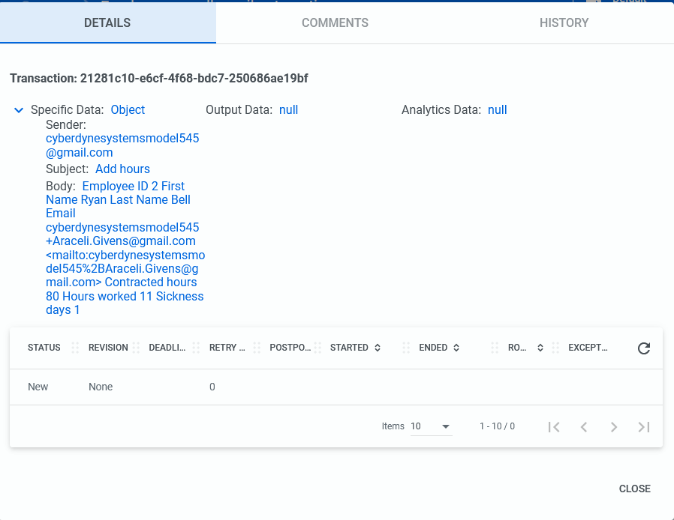

*Figure 3: A example of what a queue item would look like*

* If subject is “Add employee payroll hours”
  + Move to folder “Add employee payroll hours”
  + Add hours to the employee payroll table
* If subject is “Change employee payroll details”
  + Verify the sender email with the employee database
  + Move to folder “Change employee payroll details”
  + Change employee details in employee payroll table

### 4.1.5 *Second robot action*

**Consultant Payroll Table**

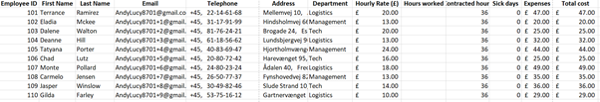

Figure 1: Consultant payroll table, showing details of each consultant

* A database will be created with a list of all the consultant employees, with their details filled, such as first name, last name, address, email address, telephone, contracted hours. Due to not having access to the company database, dummy data has been scraped using detail generators.
* This database is used as a template, with hours worked extracted from invoices and added into a copy of the template database.

**Reading through Outlook Inbox**

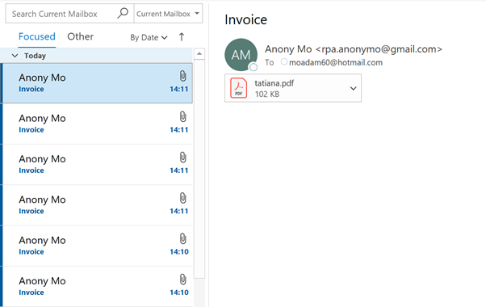

Figure 2: Example of Outlook Inbox, emails sent to be read by robot and take action

* Automation will read the email, download the attached PDF file and save this to a local folder. The email will then be moved to the “Invoice” folder. The automation will then move on to the next mail until all mail messages have been covered.
* If any emails have come through the inbox with a different subject this will be added to the “Manual Intervention” folder.

**Reading Invoice PDF Files**

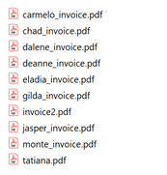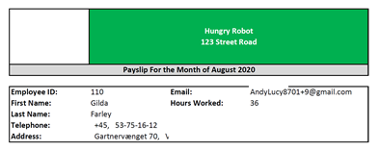

Figure 3: Screenshot of the Invoice PDF file list and a screenshot of the invoice attached by consultants,

* The automation will read through the PDF folder and add all file paths to an array. Each PDF will be converted to text and the Hours worked; email address will be extracted. These details will be added to a Queue.
* Next automation will run through the database to match each consultant by their unique email and attach their respective hours worked.

### 4.1.6 *third robot action*

* *Display a message box asking the user to verify all generated tables before continuing with the automation*
* *Access online exchange rate website and scrape the data, manipulate the data to get the numerical value of the data.*

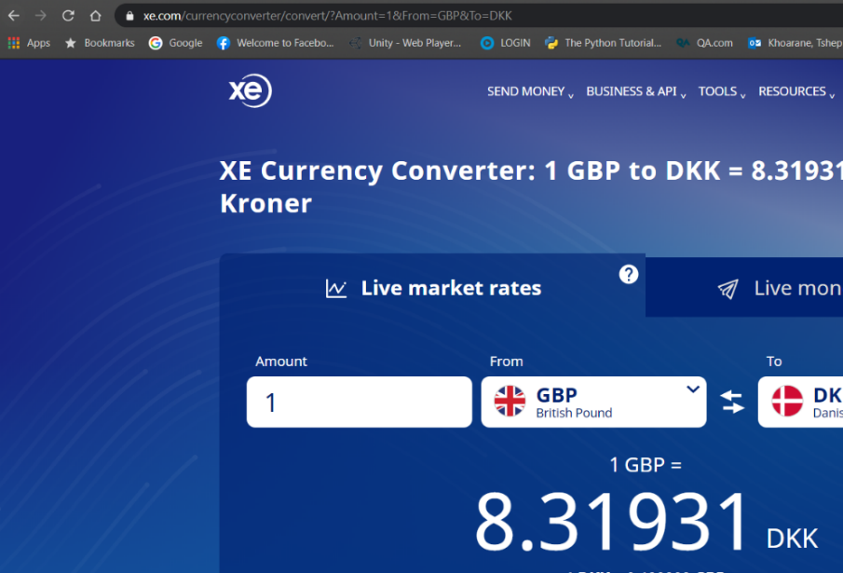

* *Multiply the value with the total pay for the consultants to get the salary in their preferred currency then update the pay period database.*

* *Write payslip for the employees and consultants and save them into the pay period folder.*

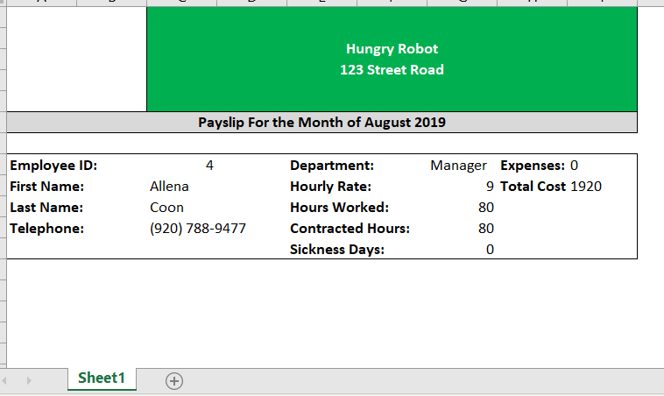

*The payslip is then converted into PDF format and then emailed to all the employees prior to their actual pay date.*

* *Display a message box with the number payslips that were processed*

## 4.2 Reporting

### 4.2.1 Business Exception

|  |  |
| --- | --- |
| Exception | Solution |
| *PDF invoice is in incorrect format for regular expression extractors to extract the correct details* | *Exception caught by the try-catch block. Exception along with time and date are stored in the log.* |
| Employees do not send in hours worked | *Exception caught by the try-catch block. Exception along with time and date are stored in the log.* |
| Employees send incorrect number of hours worked into the system | Exception caught by HR manager during review of tables. |

### 4.2.2 System Exceptions

|  |  |
| --- | --- |
| Exception | Solution |
| *Web browser not available* | *First, retry a predetermined number of times, listed in the Config file, then record exception with date, time and specific error information to the log file. Finally, display a message box describing the issue.* |
| The configuration file cannot be found when running in UiPath | *Exception caught by the try-catch block. Exception along with time and date are stored in the log.* |
| UiPath Orchestrator cannot connect to Studio | *Exception recorded in Orchestrator as a failed job.* |
| Websites used in automation are changed in some way that interferes with selectors | *Exception caught by the try-catch block. Exception along with time and date are stored in the log.* |

### 4.2.3 Triggers

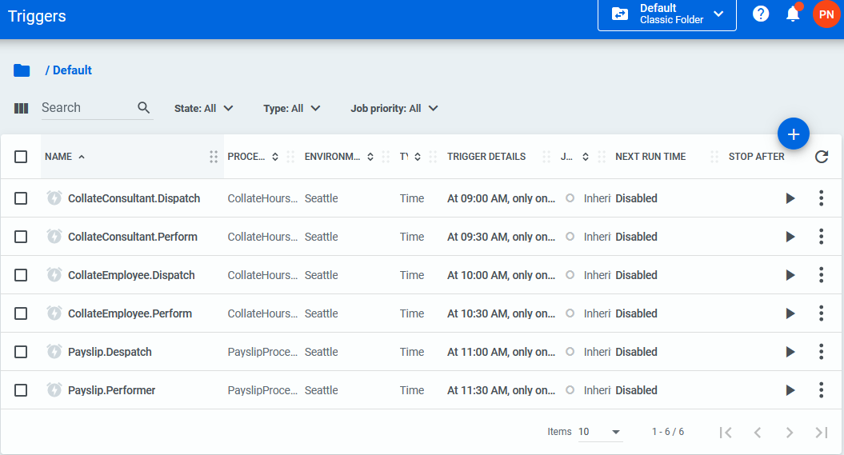

Processes will be triggered at specified times every other Friday. Processes will be triggered in 30-minute intervals to allow for enough time for each process to execute. The image above shows each the time that each process is called at. Should stop activities are included in every process to allow to running process to be stopped.